**UNIVERSITY OF CONNECTICUT’S**

**HORSE SYMPOSIUM**

**SATURDAY MARCH 29, 2025 9 AM – 12 PM**

# Cavaletti, Pole and Groundwork Clinic with Melissa Tindall

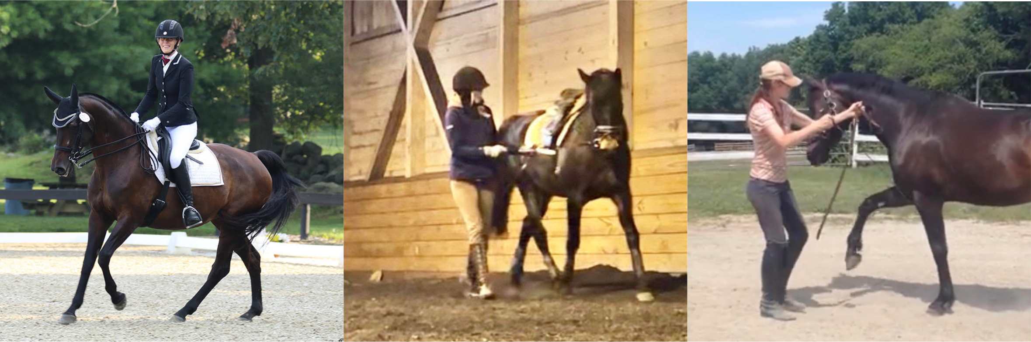

Join Melissa Tindall for a clinic where horses and riders will gain confidence and skills combining dressage principles with groundwork and pole work. Riders from all disciplines can learn the correct use of aids for lateral work on the ground to further their understanding when mounted. They can then work on improving balance and rhythm in the saddle over poles and cavaletti.

Melissa Tindall has been riding horses for 40 years and earned her USDF Bronze medal on her self-trained mare who she is currently competing at Prix St. George. She is the Coach of the UConn Dressage team, teaches riding at UConn and travels to teach locally. She was an apprentice with FEI rider and USDF Instructor faculty member Melanie Tenney, where she went through the BHS Instructor Training Program. Melissa began her riding career in hunter jumpers and eventing but has concentrated on dressage for the last 25 years. She focuses on positive teaching and training methods utilizing in-hand work, in addition to mounted work, to encourage connection and understanding of both students and horses.

**9-10 AM  
Session 1**: **In Hand Lateral Work**, limited to 12 handlers

Learn the how, when and why in asking/teaching horses to move laterally using dressage principles on the ground.

**10-11 AM**  
**Session 2: Basic Pole Exercises**, limited to 8 riders

For riders who are comfortable walk/trot over ground poles and comfortable cantering a single pole. Basic exercises designed to help the rider find balance and rhythm using dressage principles.

**11 AM -12 PM**  
**Session 3: Advanced Pole Exercises and Cavaletti,** limited to 8 riders

For riders who are comfortable walk/trot/canter over ground poles and cavaletti. More advanced exercises designed to help the rider find balance and rhythm using dressage principles.

Sign up for a clinic under “2025 CT Horse Symposium” at: <http://animalscience.uconn.edu/horseSymp/HorseSymposium.php>

“*An Equal Opportunity Employer and Program Provider*”

Registration Form – Melissa Tindall Cavaletti, Pole and Groundwork Clinic

Name: __________________________________________________________________

Address: ____________________________________________________________

Telephone:___________________________________ Fax:________________________

Email: __________________________________________________________________

What You Would Like to Learn ________________________________________________

Session: (Check each you would like to participate in, each session is priced individually)

___In Hand Lateral Work ($50, $45 4-H/UConn students/Horse Practicum participants)

___Basic Pole Exercises ($50, $45 4-H/UConn students/Horse Practicum participants))

___Advanced Pole Exercises and Cavaletti ($50, $45 4-H/UConn students/Horse Practicum participants)

___$20 to use a UConn Horse per session (put total in blank)

Name of Horse Requested (list more than one choice): _________________________________

____ $25 audit the entire day

____$10 for age 9-18, 4-H leaders/members; UConn students; youth groups, senior citizens

___ Total Amount Included

**Equine Health Form for Visiting and Donated Horses must be completed and brought with you that day including negative Coggins, a veterinary certificate if out of state, rabies within 1 yr – 28 days prior, Eastern/Western/West Nile Virus/Tetanus/Flu/Rhino within 1 year and a 3 day temperature log. You will not be allowed to unload your horse until we receive this paperwork.**

**ASTM/SEI approved helmets required for all participants as per UConn Horse Barn rules.**

Dr. Jenifer Nadeau

Department of Animal Science, University of Connecticut

17 Manter Rd, U-4040

Storrs, CT 06269-4040

If there are any questions, please call Jenifer Nadeau at (860) 486-4471, FAX at (860) 486-4375 or email [jenifer.nadeau@uconn.edu](mailto:jenifer.nadeau@uconn.edu). Must be received by 3/22/25.

“*An Equal Opportunity Employer and Program Provider*”

The University of Connecticut complies with all applicable federal and state laws regarding non-discrimination, equal opportunity and affirmative action, including the provision of reasonable accommodations for persons with disabilities. UConn does not discriminate on the basis of race, color, ethnicity, religious creed, age, sex, marital status, national origin, ancestry, sexual orientation, genetic information, physical or mental disability, veteran status, prior conviction of a crime, workplace hazards to reproductive systems, gender identity or expression, or political beliefs in its programs and activities.  Employees, students, visitors, and applicants with disabilities may request reasonable accommodations to address limitations resulting from a disability.