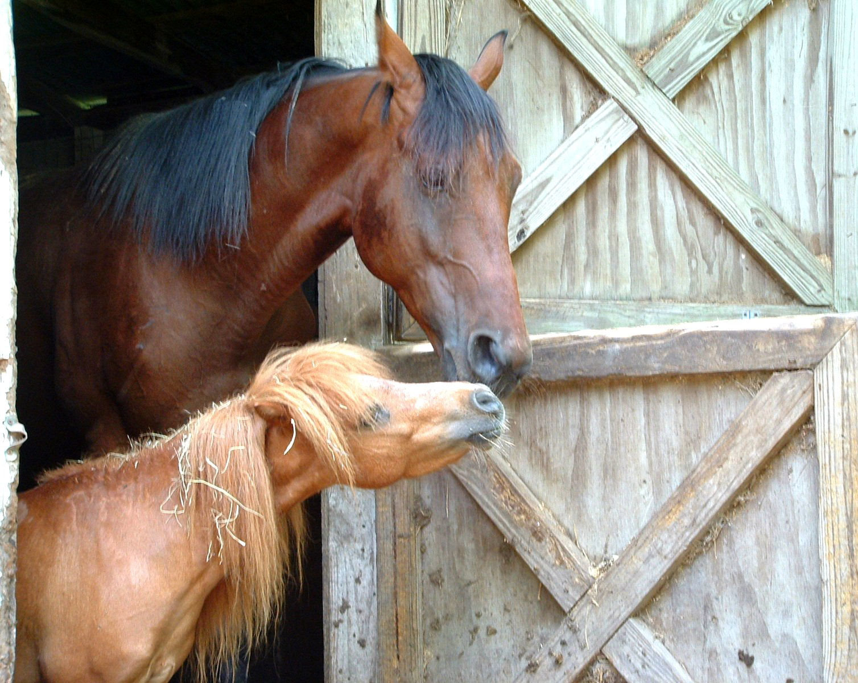

Brainstorm!
First ask the students what type of bedding they use at home. Ask them if sheets and comforters would be a good choice for the bedding in a horse’s stall.
Then, as a club brainstorm the possible bedding options for a horse. Be as creative as possible but also practical. Have members think of items that they recycle at home. Could some of those like cardboard and paper be used as bedding? During the next meeting have them bring in any and all possible bedding options they could find. Have the members decide if their choices would be safe for the horse AND safe for the environment. Create a collage of the materials or use them in the other activities.
Horses and Humans for a Healthy Habitat
Choosing the Best Bedding
Let’s face the facts, horses will never learn how to make their own beds a.k.a stalls. As owners and care-givers we must provide them with the most comfortable and safe living arrangements. Choosing the most efficient and cost effective bedding can make all the difference to the horse and stall cleaners. The following activities are designed to allow members to investigate different options available to them. They can then share their findings with peers and horse owners in their county.

Activities:

Group: Brainstorm
Ages7-8: Water Absorbency
Experiment

Ages 9-11: Investigate the
makings of wood
shavings

Ages 12-15: Advertisement
Bedding Options


Ages: 9-12
Procedure:
- In a small group of 2-4 create a guess or hypothesis about which bedding will be the most absorbent.
- Fill each sandwich container “stalls” equally with the bedding samples
- Label each stall by sample
- Pour 1/8 cup water onto each bedding sample
- Wait two minutes. Make observations about the amount of water absorbed and any changes in the bedding
- Repeat steps 4 and 5 until samples fail to absorb any more water.

4H Members will evaluate horse bedding to determine which bedding material is the most absorbent.

Materials:
Better Bedding

- Sandwich size Gladware or Tupperware containers- enough for each small group to complete the experiment
- 2-cup samples of popular bedding choices in your area. These could include: wood shavings, sawdust, shredded paper, shredded cardboard, straw, pellets
- 1/8-cup measurement.
- Water

Discussion Questions:
1. Did your hypothesis or guess prove true or false?
2. Why do you think some samples held more water than others (size of sample, particles, amount of sample per area, material of sample etc)?
3. For the samples with less water absorbed: how could they hold more water?
4. We know how much water the samples absorb, how easy do you think it would be remove manure from the bedding?

Ages: 9-12
Activities:
#1 Visit the websites below. Create a poster describing the process of making wood shavings.
#2 Compose a persuasive speech suggesting an alternative to wood shavings.

www.jacksonlbrharvester.com/shavingmills.html
www.exoticpets.about.com/cs/guineapigs/a/woodshavings.html
www.equilitter.com/comparisons.html
www.justhorses.com/50.html
This project group focuses on the source and process of making bedding materials. 4H members will have the opportunity to complete small activities that they can combine to create a final presentation about ecologically friendly bedding materials.
Objectives:
- 4H members will learn the process of making bedding materials
- 4H members will discuss the source of bedding materials. Is it recycled, synthetic, all natural?
- 4H members will research alternatives to wood shavings

Materials:

Where’d that come from??

- Poster board
- Markers/paint/crayons
- Presentation materials
- Access to a computer or video camera if necessary


Debate It!
Have a friendly debate during a club meeting about which bedding is the best. Involve all members and have the older members be leaders to the group.
Make it more fun by dressing up and having some members act as horse owners and give testimonials for the product.
If the 4H camp in your county has horses, ask them to consider using the product your club selects as the best for the environment, horses and people!

Advertise It!
Ages 11-15
Have 4H members create an advertisement for the most eco friendly bedding brand for the horse, owner and Earth. This could be a print add, video, radio ad or use any other medium.
Students could also advertise one of the alternative bedding options the club brainstormed together.
Collaborate with local businesses in the area and see if they could display the advertisement at their store.
Have members send their advertisements to the company that makes the product. They may be willing to pursue a new way of marketing and will be excited that young adults are using their products.

Compiled by: Courtney M. Murphy: Graduate Student, University of Connecticut NEAG School of Education
With Assistance from: Lauren Reynolds: Undergraduate Student, University of Connecticut College of Agriculture and Natural Resources
Under the supervision of Dr. Jenifer Nadeau, Associate Professor and Equine Extension Specialist, University of Connecticut

