*If you do not have a UConn NetID, you must identify a sponsor (full time employee) in your department and ask them to request an affiliate NetID on your behalf. The sponsor should complete this request by completing the form at the following link: http://www.affiliate.uconn.edu/.
Please note that the IACUC will accept the on-line “Working with the IACUC” course on the CITI website in place of the IACUC Classroom Training Session. Here are the instructions for the CITI website:
Step 1: Click on the link: https://www.citiprogram.org/. Then click “register.” Choose a participating institution from the search box. Select "University of Connecticut - Storrs/Regional Campuses.”
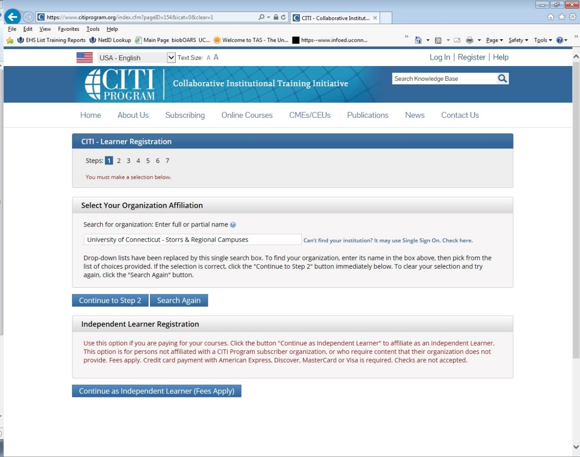
After selecting your institution click Continue to Step 2.
Step 2: Enter your first and last name along with your email address. Please enter your name here as you would like it to appear on your completion report received at the end of the course.
Ensure you use an email address that you can access so you can complete the registration process by verifying the email. You can use any email address to register but we recommend not using your institutional email. The account belongs to you, the learner, and if you leave the institution you will still have access to the account if you use a non-institutional email. This means you can keep the same account and transfer credit if you affiliate with a new institution.
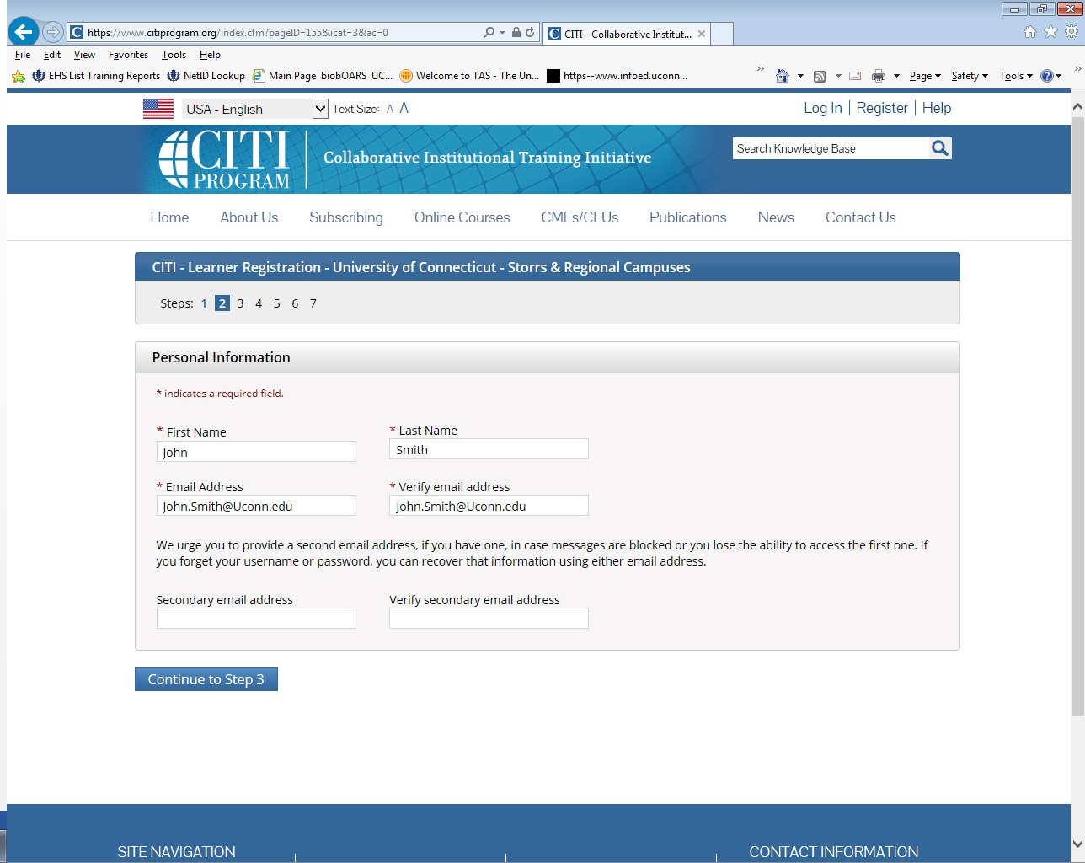
While not required, we do encourage entering a secondary email address. It will assist in the recovery of your account if you forget your username or password and no longer have access to your primary email address.
Step 3: Choose a username and password for your account. Please follow the on screen instructions for the expected parameters of each field. Passwords are case sensitive. During this step you will also select and answer a security question. This question will be used to assist in the recovery of your account if you have forgotten your username or password. Please select a question that is applicable to you and you can comfortably answer for the tech support team.
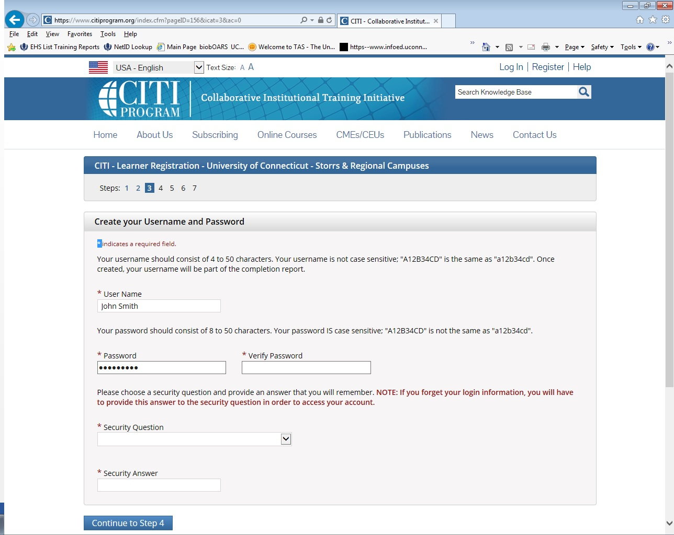
Step 4: Collects demographic information. All information provided is voluntary. Use the blue information question marks for more information on specific categories.
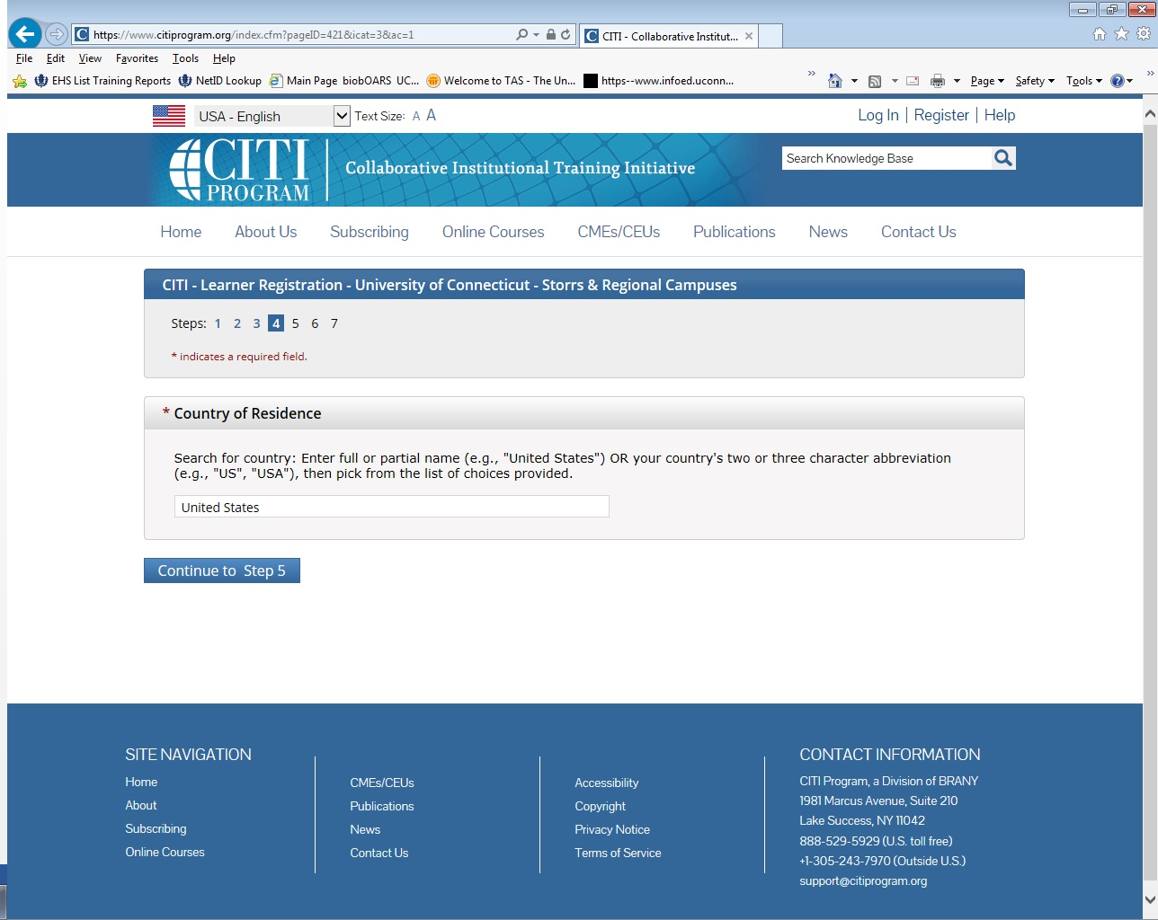

Step 5: Professionals seeking credit for CITI Program courses can make their selection for Continuing Education. This step is where you can also let CITI know your interest in participating in research surveys at a later date.
Step 6: Is institutional specific. Each institution determines the fields listed on this page and what information is required or optional. Some institutions request very specific information such as an employee ID number or campus name. Any questions regarding the fields on this page should be directed to your institution CITI Program administrator.
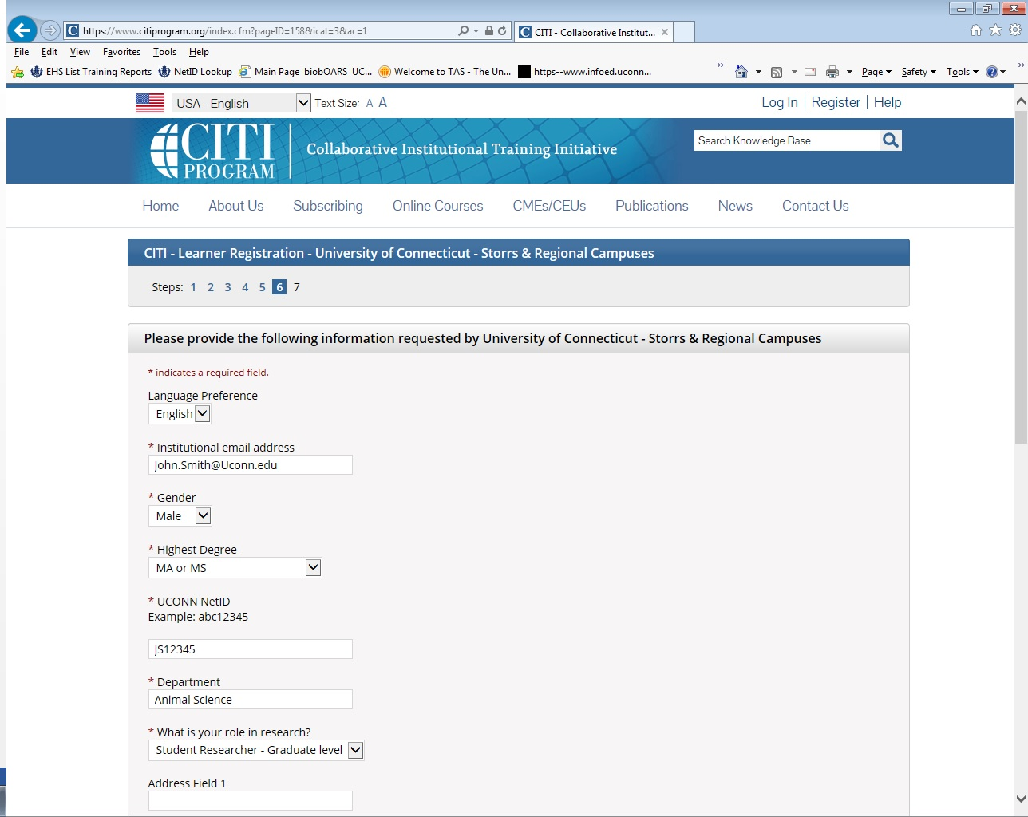
The questions in Step 7 enroll you in CITI Program courses. These questions are set up based on the institutional specific courses. Please read each question carefully to ensure you are enrolled in the correct course.
